PRACTICA 3

Ing. Carla Escobar Olivares. CALCULO II 3º A2

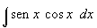
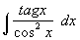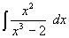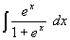
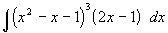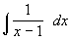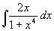
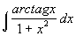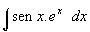
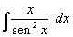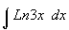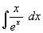
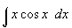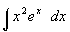
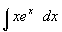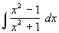
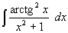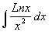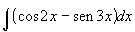
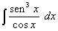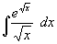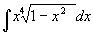
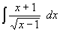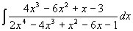
$\int{}\frac{\text{sen} x}{{}^{x^{3}}} \text{dx}$ $\int{\sqrt{9 − x^{2}} \text{dx}}$
$\int{{\text{tg}}^{2}x {\text{sec}}^{4}x \text{dx}}$ $\int{{\text{sen}}^{5}x {\text{cos}}^{3}x \text{dx}}$ $\int{\frac{\text{27}}{(x^{2}+4x+\text{13})^{2}} \text{dx}}$
$\int{\frac{1}{\sqrt{4x−x^{2}}} \text{dx}}$ $\int{\frac{x^{3}}{\sqrt{5−x^{2}}} \text{dx}}$ $\int{\frac{2x^{2}+3x+8}{x^{3}+4x} \text{dx}}$

$\int{\frac{3x−9}{x^{2}−5x+4} \text{dx}}$ $\int{\frac{x^{2}+3x−3}{x^{3}−x^{2}} \text{dx}}$ $\int{\frac{4x^{2}+7x+\text{30}}{(x+3)(x^{2}+4x+8)} \text{dx}}$

Fecha de entrega: Día del examen (15 de abril)

SUERTE !!!

